final_analysis

library(ggplot2)  
library(ggpubr)

## Loading required package: magrittr

library(plyr)

##   
## Attaching package: 'plyr'

## The following object is masked from 'package:ggpubr':  
##   
## mutate

library(lubridate)

##   
## Attaching package: 'lubridate'

## The following object is masked from 'package:plyr':  
##   
## here

## The following object is masked from 'package:base':  
##   
## date

library(dplyr)

##   
## Attaching package: 'dplyr'

## The following objects are masked from 'package:lubridate':  
##   
## intersect, setdiff, union

## The following objects are masked from 'package:plyr':  
##   
## arrange, count, desc, failwith, id, mutate, rename, summarise,  
## summarize

## The following objects are masked from 'package:stats':  
##   
## filter, lag

## The following objects are masked from 'package:base':  
##   
## intersect, setdiff, setequal, union

library(scales)  
library(gridExtra)

##   
## Attaching package: 'gridExtra'

## The following object is masked from 'package:dplyr':  
##   
## combine

LOAD DATA

movies <- get(load("movies.RData"))

#For R:   
#head(movies)   
 #For R Markdown:  
# range <- 1:8  
# range <- list(range,range+8,range+16,range+24)  
# knitr::kable(data[range[[1]]], caption = paste("From column",range[[1]][1],"to column",range[[1]][8]));  
# knitr::kable(data[range[[2]]], caption = paste("From column",range[[2]][1],"to column",range[[2]][8]));  
# knitr::kable(data[range[[3]]], caption = paste("From column",range[[3]][1],"to column",range[[3]][8]));  
# knitr::kable(data[range[[4]]], caption = paste("From column",range[[4]][1],"to column",range[[4]][8]));

summary(movies)

## title title_type genre   
## Length:651 Documentary : 55 Drama :305   
## Class :character Feature Film:591 Comedy : 87   
## Mode :character TV Movie : 5 Action & Adventure: 65   
## Mystery & Suspense: 59   
## Documentary : 52   
## Horror : 23   
## (Other) : 60   
## runtime mpaa_rating studio   
## Min. : 39.0 G : 19 Paramount Pictures : 37   
## 1st Qu.: 92.0 NC-17 : 2 Warner Bros. Pictures : 30   
## Median :103.0 PG :118 Sony Pictures Home Entertainment: 27   
## Mean :105.8 PG-13 :133 Universal Pictures : 23   
## 3rd Qu.:115.8 R :329 Warner Home Video : 19   
## Max. :267.0 Unrated: 50 (Other) :507   
## NA's :1 NA's : 8   
## thtr_rel_year thtr_rel_month thtr_rel_day dvd_rel_year   
## Min. :1970 Min. : 1.00 Min. : 1.00 Min. :1991   
## 1st Qu.:1990 1st Qu.: 4.00 1st Qu.: 7.00 1st Qu.:2001   
## Median :2000 Median : 7.00 Median :15.00 Median :2004   
## Mean :1998 Mean : 6.74 Mean :14.42 Mean :2004   
## 3rd Qu.:2007 3rd Qu.:10.00 3rd Qu.:21.00 3rd Qu.:2008   
## Max. :2014 Max. :12.00 Max. :31.00 Max. :2015   
## NA's :8   
## dvd_rel_month dvd_rel_day imdb_rating imdb_num_votes   
## Min. : 1.000 Min. : 1.00 Min. :1.900 Min. : 180   
## 1st Qu.: 3.000 1st Qu.: 7.00 1st Qu.:5.900 1st Qu.: 4546   
## Median : 6.000 Median :15.00 Median :6.600 Median : 15116   
## Mean : 6.333 Mean :15.01 Mean :6.493 Mean : 57533   
## 3rd Qu.: 9.000 3rd Qu.:23.00 3rd Qu.:7.300 3rd Qu.: 58301   
## Max. :12.000 Max. :31.00 Max. :9.000 Max. :893008   
## NA's :8 NA's :8   
## critics_rating critics_score audience_rating audience_score   
## Certified Fresh:135 Min. : 1.00 Spilled:275 Min. :11.00   
## Fresh :209 1st Qu.: 33.00 Upright:376 1st Qu.:46.00   
## Rotten :307 Median : 61.00 Median :65.00   
## Mean : 57.69 Mean :62.36   
## 3rd Qu.: 83.00 3rd Qu.:80.00   
## Max. :100.00 Max. :97.00   
##   
## best_pic_nom best_pic_win best_actor_win best_actress_win best_dir_win  
## no :629 no :644 no :558 no :579 no :608   
## yes: 22 yes: 7 yes: 93 yes: 72 yes: 43   
##   
##   
##   
##   
##   
## top200_box director actor1 actor2   
## no :636 Length:651 Length:651 Length:651   
## yes: 15 Class :character Class :character Class :character   
## Mode :character Mode :character Mode :character   
##   
##   
##   
##   
## actor3 actor4 actor5   
## Length:651 Length:651 Length:651   
## Class :character Class :character Class :character   
## Mode :character Mode :character Mode :character   
##   
##   
##   
##   
## imdb_url rt_url   
## Length:651 Length:651   
## Class :character Class :character   
## Mode :character Mode :character   
##   
##   
##   
##

TRANSFORM DATA

#Runtime:  
movies[!complete.cases(movies['runtime']),]

## title title_type genre runtime mpaa_rating studio  
## 334 The End of America Documentary Documentary NA Unrated Indipix  
## thtr_rel_year thtr_rel_month thtr_rel_day dvd_rel_year dvd_rel_month  
## 334 2008 10 1 2009 1  
## dvd_rel_day imdb_rating imdb_num_votes critics_rating critics_score  
## 334 20 7.5 739 Fresh 80  
## audience_rating audience_score best_pic_nom best_pic_win  
## 334 Upright 72 no no  
## best_actor_win best_actress_win best_dir_win top200_box director  
## 334 no no no no Anne Sundberg  
## actor1 actor2 actor3 actor4 actor5  
## 334 Naomi Wolf <NA> <NA> <NA> <NA>  
## imdb_url  
## 334 http://www.imdb.com/title/tt1294790/  
## rt_url  
## 334 //www.rottentomatoes.com/m/end_of_america/

movies$runtime[movies$title == "The End of America"] <- 74  
#https://www.imdb.com/title/tt1294790/  
  
#Director:  
movies$director[movies$title == "Lorenzo's Oil"] <- "George Miller"  
#https://es.wikipedia.org/wiki/Lorenzo%27s_Oil_(pel%C3%ADcula)  
movies$director[movies$title == "The Ninth Gate"] <- "Roman Polanski"  
#https://es.wikipedia.org/wiki/The_Ninth_Gate  
  
#Studio:  
movies$studio <- as.character(movies$studio)  
movies$studio[movies$title == "Oliver & Company"] <-  
 "Walt Disney Pictures"  
#https://es.wikipedia.org/wiki/Oliver_y_su_pandilla  
movies$studio[movies$title == "Attack of the 50 Foot Woman"] <-  
 "Woolner Brothers Pictures Inc."  
#https://www.imdb.com/title/tt0051380/  
movies$studio[movies$title == "Inbred"] <- "Melanie Light"  
#https://www.imdb.com/title/tt1723124/fullcredits  
movies$studio[movies$title == "Caveman"] <- "United Artists"  
#https://es.wikipedia.org/wiki/El_cavern%C3%ADcola  
movies$studio[movies$title == "Dirty Sanchez: The Movie"] <-  
 "Vertigo Films"  
#https://www.rottentomatoes.com/m/dirty_sanchez  
movies$studio[movies$title == "The Man Who Sued God"] <-  
 "Australian Film Finance Corporation (AFFC), New South Wales Film & Television Office, Showtime Australia See more"  
#https://www.imdb.com/title/tt0268437/  
movies$studio[movies$title == "Inserts"] <-  
 "Film and General Productions"  
#https://www.filmaffinity.com/es/film740308.html  
movies$studio <- factor(movies$studio)  
  
#DVD realease date  
movies[!complete.cases(movies['dvd_rel_year']), ]

## title title_type  
## 100 Charlie: The Life and Art of Charles Chaplin Documentary  
## 184 Streets of Gold Feature Film  
## 261 The Squeeze Feature Film  
## 345 Electric Dreams Feature Film  
## 375 Porky's Revenge Feature Film  
## 377 Teen Wolf Too Feature Film  
## 437 The Last Remake of Beau Geste Feature Film  
## 451 Let It Be Documentary  
## genre runtime mpaa_rating studio  
## 100 Documentary 132 Unrated Warner Bros.  
## 184 Drama 95 R Live Home Video  
## 261 Action & Adventure 101 PG-13 HBO Video  
## 345 Drama 95 PG MGM  
## 375 Art House & International 92 R 20th Century Fox  
## 377 Science Fiction & Fantasy 95 PG Paramount Home Video  
## 437 Action & Adventure 85 PG MCA Universal Home Video  
## 451 Documentary 81 G United Artists  
## thtr_rel_year thtr_rel_month thtr_rel_day dvd_rel_year dvd_rel_month  
## 100 2004 2 13 NA NA  
## 184 1986 11 14 NA NA  
## 261 1987 7 10 NA NA  
## 345 1984 7 20 NA NA  
## 375 1985 3 22 NA NA  
## 377 1987 11 20 NA NA  
## 437 1977 7 15 NA NA  
## 451 1970 5 20 NA NA  
## dvd_rel_day imdb_rating imdb_num_votes critics_rating critics_score  
## 100 NA 8.0 1147 Fresh 95  
## 184 NA 6.0 486 Rotten 31  
## 261 NA 4.5 703 Rotten 17  
## 345 NA 6.5 5149 Rotten 47  
## 375 NA 4.6 5863 Rotten 27  
## 377 NA 3.1 8319 Rotten 7  
## 437 NA 6.0 1680 Rotten 33  
## 451 NA 7.9 3887 Fresh 82  
## audience_rating audience_score best_pic_nom best_pic_win  
## 100 Upright 90 no no  
## 184 Spilled 44 no no  
## 261 Spilled 33 no no  
## 345 Upright 72 no no  
## 375 Spilled 33 no no  
## 377 Spilled 17 no no  
## 437 Upright 65 no no  
## 451 Upright 87 no no  
## best_actor_win best_actress_win best_dir_win top200_box  
## 100 no no no no  
## 184 no no no no  
## 261 no no no no  
## 345 no no no no  
## 375 no no no no  
## 377 no no no no  
## 437 no no no no  
## 451 no no no no  
## director actor1 actor2  
## 100 Richard Schickel Woody Allen Johnny Depp  
## 184 Joe Roth Klaus Maria Brandauer Adrian Pasdar  
## 261 Roger Young Michael Keaton Rae Dawn Chong  
## 345 Steve Barron Lenny Von Dohlen Virginia Madsen  
## 375 James Komack Dan Monahan Wyatt Knight  
## 377 Christopher Leitch Jason Bateman Kim Darby  
## 437 Marty Feldman Marty Feldman Ann-Margret  
## 451 Michael Lindsay-Hogg Beatles The Paul McCartney  
## actor3 actor4 actor5  
## 100 Sydney Pollack Milos Forman Marcel Marceau  
## 184 Richard Pasdar Wesley Snipes Angela Molina  
## 261 Meat Loaf John Davidson Ric Abernathy  
## 345 Maxwell Caulfield Bud Cort Don Fellows  
## 375 Mark Herrier Tony Ganios Kaki Hunter  
## 377 John Astin Estee Chandler Paul Sand  
## 437 Michael York Peter Ustinov James Earl Jones  
## 451 Ringo Starr George Harrison John Lennon  
## imdb_url  
## 100 http://www.imdb.com/title/tt0379730/  
## 184 http://www.imdb.com/title/tt0092022/  
## 261 http://www.imdb.com/title/tt0094021/  
## 345 http://www.imdb.com/title/tt0087197/  
## 375 http://www.imdb.com/title/tt0089826/  
## 377 http://www.imdb.com/title/tt0094118/  
## 437 http://www.imdb.com/title/tt0076297/  
## 451 http://www.imdb.com/title/tt0065976/  
## rt_url  
## 100 //www.rottentomatoes.com/m/charlie_the_life_and_art_of_charles_chaplin/  
## 184 //www.rottentomatoes.com/m/streets_of_gold/  
## 261 //www.rottentomatoes.com/m/1019743-squeeze/  
## 345 //www.rottentomatoes.com/m/1006510-electric_dreams/  
## 375 //www.rottentomatoes.com/m/porkys_revenge/  
## 377 //www.rottentomatoes.com/m/teen_wolf_too/  
## 437 //www.rottentomatoes.com/m/last_remake_of_beau_geste/  
## 451 //www.rottentomatoes.com/m/let-it-be/

movies$dvd_rel_year[movies$title == "Charlie: The Life and Art of Charles Chaplin"] <-  
 2003  
movies$dvd_rel_month[movies$title == "Charlie: The Life and Art of Charles Chaplin"] <-  
 11  
movies$dvd_rel_day[movies$title == "Charlie: The Life and Art of Charles Chaplin"] <-  
 5  
#https://www.imdb.com/title/tt0379730/releaseinfo  
movies$dvd_rel_year[movies$title == "The Squeeze"] <- 2015  
movies$dvd_rel_month[movies$title == "The Squeeze"] <- 6  
movies$dvd_rel_day[movies$title == "The Squeeze"] <- 9  
#https://medium.com/@releasebandyal/producer-michael-doven-announces-release-of-the-squeeze-on-dvd-75a982d0a047  
movies$dvd_rel_year[movies$title == "Electric Dreams"] <- 1984  
#https://en.wikipedia.org/wiki/Electric_Dreams_(film)  
movies$dvd_rel_year[movies$title == "The Last Remake of Beau Geste"] <-  
 2010  
movies$dvd_rel_month[movies$title == "The Last Remake of Beau Geste"] <-  
 1  
movies$dvd_rel_day[movies$title == "The Last Remake of Beau Geste"] <-  
 11  
#https://en.wikipedia.org/wiki/The_Last_Remake_of_Beau_Geste  
  
#Actors:  
movies[!complete.cases(movies['actor4']), ]

## title title_type  
## 6 Old Partner Documentary  
## 25 The Yes Men Fix the World Documentary  
## 131 Africa: The Serengeti Documentary  
## 175 Kicking It Documentary  
## 198 Gaza Strip Documentary  
## 223 Attack of the 50 Foot Woman TV Movie  
## 236 Closet Land Feature Film  
## 334 The End of America Documentary  
## 386 Jonestown: The Life and Death of Peoples Temple Documentary  
## 399 The Last Lions Documentary  
## 454 The Disappearance of Alice Creed Feature Film  
## 552 Saint of 9/11 Documentary  
## 574 Sea Monsters: A Prehistoric Adventure Documentary  
## genre runtime mpaa_rating  
## 6 Documentary 78 Unrated  
## 25 Documentary 87 Unrated  
## 131 Documentary 39 Unrated  
## 175 Documentary 98 Unrated  
## 198 Documentary 74 Unrated  
## 223 Other 90 R  
## 236 Mystery & Suspense 89 R  
## 334 Documentary 74 Unrated  
## 386 Documentary 86 Unrated  
## 399 Documentary 88 PG  
## 454 Mystery & Suspense 96 R  
## 552 Documentary 90 Unrated  
## 574 Documentary 40 G  
## studio thtr_rel_year thtr_rel_month  
## 6 Shcalo Media Group 2009 1  
## 25 Cinetic Media 2009 1  
## 131 Houston Museum of Natural Scie 1994 4  
## 175 Liberation Entertainment 2008 6  
## 198 Arab Film Distribution 2002 1  
## 223 Woolner Brothers Pictures Inc. 1993 12  
## 236 Media Home Entertainment 1991 3  
## 334 Indipix 2008 10  
## 386 7th art 2006 10  
## 399 National Geographic Entertainment 2011 2  
## 454 Anchor Bay Entertainment 2010 8  
## 552 IFC 2006 9  
## 574 National Geographic 2007 10  
## thtr_rel_day dvd_rel_year dvd_rel_month dvd_rel_day imdb_rating  
## 6 15 2010 4 20 7.8  
## 25 18 2010 4 1 7.6  
## 131 8 1998 11 18 7.3  
## 175 13 2008 9 9 7.4  
## 198 1 2003 5 6 7.3  
## 223 11 2002 4 2 3.8  
## 236 6 1991 9 12 7.2  
## 334 1 2009 1 20 7.5  
## 386 20 2007 4 10 7.9  
## 399 18 2012 1 3 8.4  
## 454 6 2010 11 23 6.8  
## 552 6 2006 9 12 7.8  
## 574 5 2008 6 24 7.0  
## imdb_num_votes critics_rating critics_score audience_rating  
## 6 333 Fresh 91 Upright  
## 25 4541 Certified Fresh 79 Upright  
## 131 535 Fresh 100 Upright  
## 175 325 Rotten 53 Upright  
## 198 285 Fresh 78 Upright  
## 223 2289 Rotten 22 Spilled  
## 236 2098 Rotten 44 Upright  
## 334 739 Fresh 80 Upright  
## 386 3649 Certified Fresh 94 Upright  
## 399 3128 Fresh 87 Upright  
## 454 19937 Certified Fresh 82 Upright  
## 552 180 Fresh 84 Upright  
## 574 723 Fresh 100 Upright  
## audience_score best_pic_nom best_pic_win best_actor_win  
## 6 86 no no no  
## 25 77 no no no  
## 131 74 no no no  
## 175 71 no no no  
## 198 89 no no no  
## 223 21 no no no  
## 236 86 no no no  
## 334 72 no no no  
## 386 88 no no no  
## 399 89 no no yes  
## 454 67 no no no  
## 552 79 no no no  
## 574 68 no no no  
## best_actress_win best_dir_win top200_box director  
## 6 no no no Chung-ryoul Lee  
## 25 no no no Andy Bichlbaum  
## 131 no no no George Casey  
## 175 no no no Jeff Werner  
## 198 no no no James Longley  
## 223 no no no Christopher Guest  
## 236 no no no Radha Bharadwaj  
## 334 no no no Anne Sundberg  
## 386 no no no Stanley Nelson  
## 399 no no no Dereck Joubert  
## 454 no no no J Blakeson  
## 552 no no no Glenn Holsten  
## 574 no no no Sean MacLeod Phillips  
## actor1 actor2 actor3 actor4 actor5  
## 6 Choi Won-kyun Lee Sam-soon Moo <NA> <NA>  
## 25 Andy Bichlbaum Reggie Waits Mike Bonanno <NA> <NA>  
## 131 James Earl Jones <NA> <NA> <NA> <NA>  
## 175 Colin Farrell Brandon Francis <NA> <NA> <NA>  
## 198 <NA> <NA> <NA> <NA> <NA>  
## 223 Daryl Hannah Daniel Baldwin Xander Berkeley <NA> <NA>  
## 236 Madeleine Stowe Alan Rickman <NA> <NA> <NA>  
## 334 Naomi Wolf <NA> <NA> <NA> <NA>  
## 386 <NA> <NA> <NA> <NA> <NA>  
## 399 Jeremy Irons <NA> <NA> <NA> <NA>  
## 454 Gemma Arterton Martin Compston Eddie Marsan <NA> <NA>  
## 552 Ian McKellen <NA> <NA> <NA> <NA>  
## 574 Liev Schreiber <NA> <NA> <NA> <NA>  
## imdb_url  
## 6 http://www.imdb.com/title/tt1334549/  
## 25 http://www.imdb.com/title/tt1352852/  
## 131 http://www.imdb.com/title/tt0109049/  
## 175 http://www.imdb.com/title/tt1157668/  
## 198 http://www.imdb.com/title/tt0329112/  
## 223 http://www.imdb.com/title/tt0106317/  
## 236 http://www.imdb.com/title/tt0101597/  
## 334 http://www.imdb.com/title/tt1294790/  
## 386 http://www.imdb.com/title/tt0762111/  
## 399 http://www.imdb.com/title/tt1692928/  
## 454 http://www.imdb.com/title/tt1379177/  
## 552 http://www.imdb.com/title/tt0795458/  
## 574 http://www.imdb.com/title/tt1027743/  
## rt_url  
## 6 //www.rottentomatoes.com/m/old-partner/  
## 25 //www.rottentomatoes.com/m/yes_men_fix_the_world/  
## 131 //www.rottentomatoes.com/m/imax_africa_the_serengeti/  
## 175 //www.rottentomatoes.com/m/kicking_it/  
## 198 //www.rottentomatoes.com/m/gaza_strip/  
## 223 //www.rottentomatoes.com/m/1050445-attack_of_the_50_foot_woman/  
## 236 //www.rottentomatoes.com/m/closet_land/  
## 334 //www.rottentomatoes.com/m/end_of_america/  
## 386 //www.rottentomatoes.com/m/jonestown_the_life_and_death_of_peoples_temple/  
## 399 //www.rottentomatoes.com/m/the_last_lions/  
## 454 //www.rottentomatoes.com/m/disappearance_of_alice_creed/  
## 552 //www.rottentomatoes.com/m/saint_of_911/  
## 574 //www.rottentomatoes.com/m/sea_monsters_a_prehistoric_adventure/

movies$actor4[movies$title == "Attack of the 50 Foot Woman"] <-  
 "Roy Gordon"  
#https://www.imdb.com/title/tt0051380/fullcredits/?ref_=tt_ov_st_sm  
  
movies[!complete.cases(movies['actor5']), ]

## title title_type  
## 6 Old Partner Documentary  
## 25 The Yes Men Fix the World Documentary  
## 131 Africa: The Serengeti Documentary  
## 175 Kicking It Documentary  
## 198 Gaza Strip Documentary  
## 223 Attack of the 50 Foot Woman TV Movie  
## 236 Closet Land Feature Film  
## 334 The End of America Documentary  
## 386 Jonestown: The Life and Death of Peoples Temple Documentary  
## 399 The Last Lions Documentary  
## 454 The Disappearance of Alice Creed Feature Film  
## 507 My Dinner with Andre Feature Film  
## 552 Saint of 9/11 Documentary  
## 574 Sea Monsters: A Prehistoric Adventure Documentary  
## 609 The Illusionist (L'illusionniste) Feature Film  
## genre runtime mpaa_rating  
## 6 Documentary 78 Unrated  
## 25 Documentary 87 Unrated  
## 131 Documentary 39 Unrated  
## 175 Documentary 98 Unrated  
## 198 Documentary 74 Unrated  
## 223 Other 90 R  
## 236 Mystery & Suspense 89 R  
## 334 Documentary 74 Unrated  
## 386 Documentary 86 Unrated  
## 399 Documentary 88 PG  
## 454 Mystery & Suspense 96 R  
## 507 Drama 110 PG  
## 552 Documentary 90 Unrated  
## 574 Documentary 40 G  
## 609 Drama 80 PG  
## studio thtr_rel_year thtr_rel_month  
## 6 Shcalo Media Group 2009 1  
## 25 Cinetic Media 2009 1  
## 131 Houston Museum of Natural Scie 1994 4  
## 175 Liberation Entertainment 2008 6  
## 198 Arab Film Distribution 2002 1  
## 223 Woolner Brothers Pictures Inc. 1993 12  
## 236 Media Home Entertainment 1991 3  
## 334 Indipix 2008 10  
## 386 7th art 2006 10  
## 399 National Geographic Entertainment 2011 2  
## 454 Anchor Bay Entertainment 2010 8  
## 507 New Yorker Films 1981 10  
## 552 IFC 2006 9  
## 574 National Geographic 2007 10  
## 609 Sony Pictures Classics 2010 12  
## thtr_rel_day dvd_rel_year dvd_rel_month dvd_rel_day imdb_rating  
## 6 15 2010 4 20 7.8  
## 25 18 2010 4 1 7.6  
## 131 8 1998 11 18 7.3  
## 175 13 2008 9 9 7.4  
## 198 1 2003 5 6 7.3  
## 223 11 2002 4 2 3.8  
## 236 6 1991 9 12 7.2  
## 334 1 2009 1 20 7.5  
## 386 20 2007 4 10 7.9  
## 399 18 2012 1 3 8.4  
## 454 6 2010 11 23 6.8  
## 507 11 2001 2 13 7.8  
## 552 6 2006 9 12 7.8  
## 574 5 2008 6 24 7.0  
## 609 25 2011 5 10 7.5  
## imdb_num_votes critics_rating critics_score audience_rating  
## 6 333 Fresh 91 Upright  
## 25 4541 Certified Fresh 79 Upright  
## 131 535 Fresh 100 Upright  
## 175 325 Rotten 53 Upright  
## 198 285 Fresh 78 Upright  
## 223 2289 Rotten 22 Spilled  
## 236 2098 Rotten 44 Upright  
## 334 739 Fresh 80 Upright  
## 386 3649 Certified Fresh 94 Upright  
## 399 3128 Fresh 87 Upright  
## 454 19937 Certified Fresh 82 Upright  
## 507 10522 Fresh 91 Upright  
## 552 180 Fresh 84 Upright  
## 574 723 Fresh 100 Upright  
## 609 27601 Certified Fresh 90 Upright  
## audience_score best_pic_nom best_pic_win best_actor_win  
## 6 86 no no no  
## 25 77 no no no  
## 131 74 no no no  
## 175 71 no no no  
## 198 89 no no no  
## 223 21 no no no  
## 236 86 no no no  
## 334 72 no no no  
## 386 88 no no no  
## 399 89 no no yes  
## 454 67 no no no  
## 507 86 no no no  
## 552 79 no no no  
## 574 68 no no no  
## 609 79 no no no  
## best_actress_win best_dir_win top200_box director  
## 6 no no no Chung-ryoul Lee  
## 25 no no no Andy Bichlbaum  
## 131 no no no George Casey  
## 175 no no no Jeff Werner  
## 198 no no no James Longley  
## 223 no no no Christopher Guest  
## 236 no no no Radha Bharadwaj  
## 334 no no no Anne Sundberg  
## 386 no no no Stanley Nelson  
## 399 no no no Dereck Joubert  
## 454 no no no J Blakeson  
## 507 no no no Louis Malle  
## 552 no no no Glenn Holsten  
## 574 no no no Sean MacLeod Phillips  
## 609 no no no Sylvain Chomet  
## actor1 actor2 actor3 actor4  
## 6 Choi Won-kyun Lee Sam-soon Moo <NA>  
## 25 Andy Bichlbaum Reggie Waits Mike Bonanno <NA>  
## 131 James Earl Jones <NA> <NA> <NA>  
## 175 Colin Farrell Brandon Francis <NA> <NA>  
## 198 <NA> <NA> <NA> <NA>  
## 223 Daryl Hannah Daniel Baldwin Xander Berkeley Roy Gordon  
## 236 Madeleine Stowe Alan Rickman <NA> <NA>  
## 334 Naomi Wolf <NA> <NA> <NA>  
## 386 <NA> <NA> <NA> <NA>  
## 399 Jeremy Irons <NA> <NA> <NA>  
## 454 Gemma Arterton Martin Compston Eddie Marsan <NA>  
## 507 Jean Lenauer Roy Butler Andre Gregory Wallace Shawn  
## 552 Ian McKellen <NA> <NA> <NA>  
## 574 Liev Schreiber <NA> <NA> <NA>  
## 609 Jean-Claude Donda Eilidh Rankin Duncan MacNeil Raymond Mearns  
## actor5 imdb_url  
## 6 <NA> http://www.imdb.com/title/tt1334549/  
## 25 <NA> http://www.imdb.com/title/tt1352852/  
## 131 <NA> http://www.imdb.com/title/tt0109049/  
## 175 <NA> http://www.imdb.com/title/tt1157668/  
## 198 <NA> http://www.imdb.com/title/tt0329112/  
## 223 <NA> http://www.imdb.com/title/tt0106317/  
## 236 <NA> http://www.imdb.com/title/tt0101597/  
## 334 <NA> http://www.imdb.com/title/tt1294790/  
## 386 <NA> http://www.imdb.com/title/tt0762111/  
## 399 <NA> http://www.imdb.com/title/tt1692928/  
## 454 <NA> http://www.imdb.com/title/tt1379177/  
## 507 <NA> http://www.imdb.com/title/tt0082783/  
## 552 <NA> http://www.imdb.com/title/tt0795458/  
## 574 <NA> http://www.imdb.com/title/tt1027743/  
## 609 <NA> http://www.imdb.com/title/tt0775489/  
## rt_url  
## 6 //www.rottentomatoes.com/m/old-partner/  
## 25 //www.rottentomatoes.com/m/yes_men_fix_the_world/  
## 131 //www.rottentomatoes.com/m/imax_africa_the_serengeti/  
## 175 //www.rottentomatoes.com/m/kicking_it/  
## 198 //www.rottentomatoes.com/m/gaza_strip/  
## 223 //www.rottentomatoes.com/m/1050445-attack_of_the_50_foot_woman/  
## 236 //www.rottentomatoes.com/m/closet_land/  
## 334 //www.rottentomatoes.com/m/end_of_america/  
## 386 //www.rottentomatoes.com/m/jonestown_the_life_and_death_of_peoples_temple/  
## 399 //www.rottentomatoes.com/m/the_last_lions/  
## 454 //www.rottentomatoes.com/m/disappearance_of_alice_creed/  
## 507 //www.rottentomatoes.com/m/my_dinner_with_andre/  
## 552 //www.rottentomatoes.com/m/saint_of_911/  
## 574 //www.rottentomatoes.com/m/sea_monsters_a_prehistoric_adventure/  
## 609 //www.rottentomatoes.com/m/the_illusionist-2009/

movies$actor5[movies$title == "Attack of the 50 Foot Woman"] <-  
 "George Douglas"  
#https://www.imdb.com/title/tt0051380/fullcredits/?ref_=tt_ov_st_sm  
movies$actor5[movies$title == "The Illusionist (L'illusionniste)"] <-  
 "Eleanor Tomlinson"  
#https://en.wikipedia.org/wiki/The_Illusionist_(2006_film)  
  
# We found that one movie had won a movie award but it didn't appear as nominated  
ggplot(aes(x=best_pic_nom), data=movies[movies$best_pic_win=="yes",]) +  
 geom_bar(aes( fill = best_dir_win)) +  
 theme_minimal() +  
 xlab("") +   
 ylab("Number of samples") +  
 scale_fill_discrete("Best picture nominated")

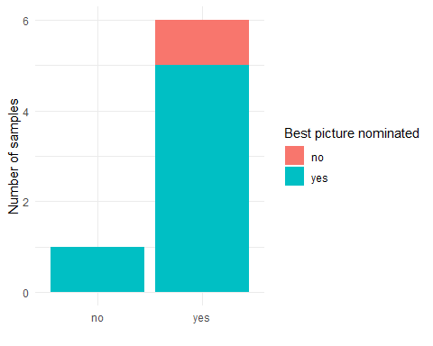

movies[movies$best_pic_nom=="no" & movies$best_pic_win=="yes",]

## title title_type genre runtime mpaa_rating  
## 382 The Hurt Locker Feature Film Drama 131 R  
## studio thtr_rel_year thtr_rel_month thtr_rel_day  
## 382 Summit Entertainment 2009 6 26  
## dvd_rel_year dvd_rel_month dvd_rel_day imdb_rating imdb_num_votes  
## 382 2010 1 12 7.6 318019  
## critics_rating critics_score audience_rating audience_score  
## 382 Certified Fresh 98 Upright 84  
## best_pic_nom best_pic_win best_actor_win best_actress_win best_dir_win  
## 382 no yes no no yes  
## top200_box director actor1 actor2 actor3  
## 382 no Kathryn Bigelow Jeremy Renner Anthony Mackie Brian Geraghty  
## actor4 actor5 imdb_url  
## 382 Guy Pearce Ralph Fiennes http://www.imdb.com/title/tt0887912/  
## rt_url  
## 382 //www.rottentomatoes.com/m/hurt_locker/

movies[movies$best_pic_nom=="no" & movies$best_pic_win=="yes",]$best_pic_nom <- "yes"  
  
  
#Column manipulation  
movies$thtr_rel_date <- as.Date(paste0(movies$thtr_rel_year, "-", movies$thtr_rel_month, "-", movies$thtr_rel_day))  
movies$dvd_rel_date <- as.Date(paste0(movies$dvd_rel_year, "-", movies$dvd_rel_month, "-", movies$dvd_rel_day))  
  
movies$thtr_rel_decade <- as.numeric(format(movies$thtr_rel_date,"%Y")) - (as.numeric(format(movies$thtr_rel_date,"%Y")) %% 10)  
movies$thtr_rel_decade <- as.factor(paste(as.factor(movies$thtr_rel_decade),'s', sep = '\''))  
  
movies$top200_box <- NULL  
  
movies$dvd_rel_day <- NULL  
movies$dvd_rel_month <- NULL  
movies$dvd_rel_year <- NULL  
  
#movies$thtr_rel_day <- NULL  
#movies$thtr_rel_month <- NULL  
#movies$thtr_rel_year <- NULL  
  
movies$imdb_url <- NULL  
movies$rt_url <- NULL

head(movies)

## title title_type genre runtime mpaa_rating  
## 1 Filly Brown Feature Film Drama 80 R  
## 2 The Dish Feature Film Drama 101 PG-13  
## 3 Waiting for Guffman Feature Film Comedy 84 R  
## 4 The Age of Innocence Feature Film Drama 139 PG  
## 5 Malevolence Feature Film Horror 90 R  
## 6 Old Partner Documentary Documentary 78 Unrated  
## studio thtr_rel_year thtr_rel_month thtr_rel_day  
## 1 Indomina Media Inc. 2013 4 19  
## 2 Warner Bros. Pictures 2001 3 14  
## 3 Sony Pictures Classics 1996 8 21  
## 4 Columbia Pictures 1993 10 1  
## 5 Anchor Bay Entertainment 2004 9 10  
## 6 Shcalo Media Group 2009 1 15  
## imdb_rating imdb_num_votes critics_rating critics_score audience_rating  
## 1 5.5 899 Rotten 45 Upright  
## 2 7.3 12285 Certified Fresh 96 Upright  
## 3 7.6 22381 Certified Fresh 91 Upright  
## 4 7.2 35096 Certified Fresh 80 Upright  
## 5 5.1 2386 Rotten 33 Spilled  
## 6 7.8 333 Fresh 91 Upright  
## audience_score best_pic_nom best_pic_win best_actor_win best_actress_win  
## 1 73 no no no no  
## 2 81 no no no no  
## 3 91 no no no no  
## 4 76 no no yes no  
## 5 27 no no no no  
## 6 86 no no no no  
## best_dir_win director actor1 actor2  
## 1 no Michael D. Olmos Gina Rodriguez Jenni Rivera  
## 2 no Rob Sitch Sam Neill Kevin Harrington  
## 3 no Christopher Guest Christopher Guest Catherine O'Hara  
## 4 yes Martin Scorsese Daniel Day-Lewis Michelle Pfeiffer  
## 5 no Stevan Mena Samantha Dark R. Brandon Johnson  
## 6 no Chung-ryoul Lee Choi Won-kyun Lee Sam-soon  
## actor3 actor4 actor5 thtr_rel_date  
## 1 Lou Diamond Phillips Emilio Rivera Joseph Julian Soria 2013-04-19  
## 2 Patrick Warburton Tom Long Genevieve Mooy 2001-03-14  
## 3 Parker Posey Eugene Levy Bob Balaban 1996-08-21  
## 4 Winona Ryder Richard E. Grant Alec McCowen 1993-10-01  
## 5 Brandon Johnson Heather Magee Richard Glover 2004-09-10  
## 6 Moo <NA> <NA> 2009-01-15  
## dvd_rel_date thtr_rel_decade  
## 1 2013-07-30 2010's  
## 2 2001-08-28 2000's  
## 3 2001-08-21 1990's  
## 4 2001-11-06 1990's  
## 5 2005-04-19 2000's  
## 6 2010-04-20 2000's

summary(movies)

## title title_type genre   
## Length:651 Documentary : 55 Drama :305   
## Class :character Feature Film:591 Comedy : 87   
## Mode :character TV Movie : 5 Action & Adventure: 65   
## Mystery & Suspense: 59   
## Documentary : 52   
## Horror : 23   
## (Other) : 60   
## runtime mpaa_rating studio   
## Min. : 39.0 G : 19 Paramount Pictures : 37   
## 1st Qu.: 92.0 NC-17 : 2 Warner Bros. Pictures : 30   
## Median :103.0 PG :118 Sony Pictures Home Entertainment: 27   
## Mean :105.8 PG-13 :133 Universal Pictures : 23   
## 3rd Qu.:115.5 R :329 Warner Home Video : 19   
## Max. :267.0 Unrated: 50 (Other) :514   
## NA's : 1   
## thtr_rel_year thtr_rel_month thtr_rel_day imdb_rating   
## Min. :1970 Min. : 1.00 Min. : 1.00 Min. :1.900   
## 1st Qu.:1990 1st Qu.: 4.00 1st Qu.: 7.00 1st Qu.:5.900   
## Median :2000 Median : 7.00 Median :15.00 Median :6.600   
## Mean :1998 Mean : 6.74 Mean :14.42 Mean :6.493   
## 3rd Qu.:2007 3rd Qu.:10.00 3rd Qu.:21.00 3rd Qu.:7.300   
## Max. :2014 Max. :12.00 Max. :31.00 Max. :9.000   
##   
## imdb_num_votes critics_rating critics_score audience_rating  
## Min. : 180 Certified Fresh:135 Min. : 1.00 Spilled:275   
## 1st Qu.: 4546 Fresh :209 1st Qu.: 33.00 Upright:376   
## Median : 15116 Rotten :307 Median : 61.00   
## Mean : 57533 Mean : 57.69   
## 3rd Qu.: 58301 3rd Qu.: 83.00   
## Max. :893008 Max. :100.00   
##   
## audience_score best_pic_nom best_pic_win best_actor_win best_actress_win  
## Min. :11.00 no :628 no :644 no :558 no :579   
## 1st Qu.:46.00 yes: 23 yes: 7 yes: 93 yes: 72   
## Median :65.00   
## Mean :62.36   
## 3rd Qu.:80.00   
## Max. :97.00   
##   
## best_dir_win director actor1 actor2   
## no :608 Length:651 Length:651 Length:651   
## yes: 43 Class :character Class :character Class :character   
## Mode :character Mode :character Mode :character   
##   
##   
##   
##   
## actor3 actor4 actor5   
## Length:651 Length:651 Length:651   
## Class :character Class :character Class :character   
## Mode :character Mode :character Mode :character   
##   
##   
##   
##   
## thtr_rel_date dvd_rel_date thtr_rel_decade  
## Min. :1970-05-20 Min. :1991-03-28 1970's: 51   
## 1st Qu.:1990-12-07 1st Qu.:2001-05-15 1980's:103   
## Median :2000-09-15 Median :2004-03-02 1990's:161   
## Mean :1998-06-15 Mean :2004-12-06 2000's:234   
## 3rd Qu.:2007-05-17 3rd Qu.:2008-02-19 2010's:102   
## Max. :2014-12-25 Max. :2015-06-09   
## NA's :5

# SDA Homework 1.1

We chose the “Films” dataset and we are going to answer the following questions that we thought were interesting.

### 1. Is there a relationship between the type/genre and score?

### 2. Comparing different scores (critics/audience/imdb)

* Is there any difference on the audience/critics score by genre?
* Is there any difference on the audience/critics score by MPAA?

### 3. Comparison best picture/oscar wins and score/oscar wins

* Are oscar-awarded films more liked?

### 4. What are the trends over the years?

* Preferred month for releases? number of films by month (over the years? does it affect the score?)
* Does the genre change over the years?
* Do older films tend to have higher score/number of votes? if this is true, it could be because only good old films get remembered

### 5. Do actors and directors have a higher score once they won? (find the first film and see the tendency, look for sudden change)

## 1. Is there a relationship between the type/genre and score?

g1_1_1 <- ggplot(data=movies, aes(x=audience_score)) +  
 geom_histogram(bins=30, aes(fill = title_type), position = "identity", alpha = 0.7) +  
 scale_color_manual(values = c("tomato", "skyblue", "limegreen")) +  
 scale_fill_manual(values = c("tomato", "skyblue", "limegreen")) +  
 #scale_x_continuous(breaks = 1:100,labels = 1:100) +   
 xlab("Audience Score") +  
 ylab("Number of samples") +  
 ylim(0,75) +  
 theme_minimal() +  
 theme(legend.position = "none")  
  
g1_1_2 <- ggplot(data=movies, aes(x=critics_score)) +  
 geom_histogram(bins=30, aes(fill = title_type), position = "identity", alpha = 0.7) +  
 scale_color_manual(values = c("tomato", "skyblue", "limegreen")) +  
 scale_fill_manual(values = c("tomato", "skyblue", "limegreen")) +  
 #scale_x_continuous(breaks = 1:100,labels = 1:100) +   
 xlab("Critics Score") +  
 ylab("") +  
 ylim(0,75) +  
 theme_minimal() +  
 theme(legend.position = "none")  
  
g1_1_3 <- ggplot(data=movies, aes(x=imdb_rating)) +  
 geom_histogram(bins=30, aes(fill = title_type), position = "identity", alpha = 0.7) +   
 scale_color_manual(values = c("tomato", "skyblue", "limegreen")) +  
 scale_fill_manual("Title Type",values = c("tomato", "skyblue", "limegreen")) +  
 scale_x_continuous(breaks = seq(0,8,2),labels = seq(0,100,25)) +   
 xlab("IMDB Score") +  
 ylab("") +  
 ylim(0,75) +  
 theme_minimal() +  
 theme(legend.position = "right")  
  
g1_1 <- ggarrange(  
 g1_1_1,  
 g1_1_2,  
 g1_1_3,  
 ncol = 3,  
 nrow = 1,  
 widths = c(200,200,330)  
 ) %>% annotate_figure(top = text_grob("Distribution of Movies for each scoring source", face = "bold"))  
  
g1_1

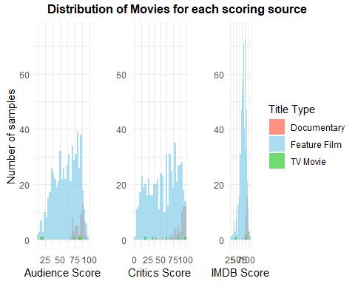

g1_2_1 <- ggplot(data=movies, aes(x=audience_score)) +  
 geom_density(aes(fill = title_type), kernel = "gaussian", alpha = 0.3)+  
 scale_fill_manual("Title Type",values = c("tomato", "skyblue", "limegreen")) +   
 xlab("Audience Score") +  
 ylab("Density") +  
 xlim(0,100) +  
 ylim(0,0.11) +  
 theme_minimal() +  
 theme(legend.position = "none")  
  
g1_2_2 <- ggplot(data=movies, aes(x=critics_score)) +  
 geom_density(aes(fill = title_type), kernel = "gaussian", alpha = 0.3)+  
 scale_fill_manual("Title Type",values = c("tomato", "skyblue", "limegreen")) +   
 #scale_y_continuous(seq(0,1,0.1)) +  
 xlab("Critics Score") +  
 ylab("") +  
 xlim(0,100) +  
 ylim(0,0.11) +  
 theme_minimal() +  
 theme(legend.position = "none")  
  
g1_2_3 <- ggplot(data=movies, aes(x=imdb_rating*10)) +  
 geom_density(aes(fill = title_type), kernel = "gaussian", alpha = 0.3)+  
 scale_fill_manual("Title Type",values = c("tomato", "skyblue", "limegreen")) +   
 #scale_y_continuous(seq(0,1,0.1)) +  
 xlab("IMDB Score") +  
 ylab("") +  
 xlim(0,100) +  
 ylim(0,0.11) +  
 theme_minimal() +  
 theme(legend.position = "right")  
  
g1_2 <- ggarrange(  
 g1_2_1,  
 g1_2_2,  
 g1_2_3,  
 ncol = 3,  
 nrow = 1,  
 widths = c(200,200,330)  
 ) %>% annotate_figure( top = text_grob("Distribution of Movies for each scoring source", face = "bold"))  
  
g1_2

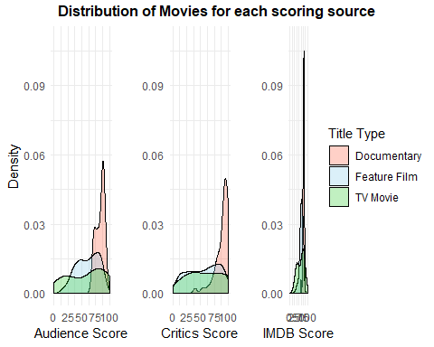

g1_3_1 <- ggplot(data=movies, aes(x = reorder(genre, audience_score, median, order=TRUE), y = audience_score, group = genre, fill = genre)) +  
 geom_boxplot(alpha = .7) +  
 geom_jitter(width = .05, alpha = .4) +  
 guides(fill = "none") +  
 xlab("Genre") +  
 #xlim(0,100) +  
 ylab("Score") +  
 theme_minimal() +  
 coord_flip()  
  
g1_3_2 <- ggplot(data=movies, aes(x = reorder(genre, audience_score, median, order=TRUE), y = critics_score, group = genre, fill = genre)) +  
 geom_boxplot(alpha = .7) +  
 geom_jitter(width = .05, alpha = .4) +  
 guides(fill = "none") +  
 xlab(" ") +  
 #xlim(0,100) +  
 ylab("Score") +  
 theme_minimal() +  
 theme(axis.text.y = element_blank(), axis.ticks.y = element_blank()) +  
 coord_flip()  
  
g1_3_3 <- ggplot(data=movies, aes(x = reorder(genre, audience_score, median, order=TRUE), y = imdb_rating*10, group = genre, fill = genre)) +  
 geom_boxplot(alpha = .7) +  
 geom_jitter(width = .05, alpha = .4) +  
 guides(fill = "none") +  
 xlab(" ") +  
 #xlim(0,100) +  
 ylab("Score") +  
 theme_minimal() +  
 theme(axis.text.y = element_blank(), axis.ticks.y = element_blank()) +  
 coord_flip()  
  
g1_3 <- ggarrange(  
 g1_3_1,  
 g1_3_2,  
 g1_3_3,  
 ncol = 3,  
 nrow = 1,  
 widths = c(300,200,200)  
 ) %>% annotate_figure( top = text_grob("Genre rating of Movies for each scoring source", face = "bold"))  
  
g1_3

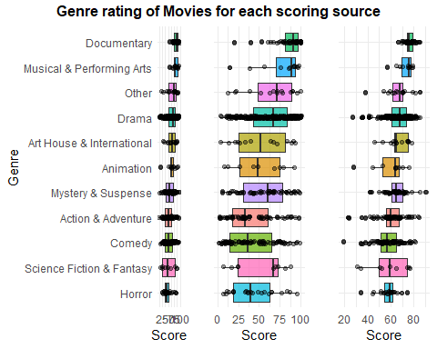

## 2. Comparing different scores (critics/audience/imdb)

### - Is there any difference on the audience/critics score by genre?

### - Is there any difference on the audience/critics score by MPAA score?

score = list();  
  
score$genre_score_agg = list(  
 "critics" = aggregate(critics_score ~ genre , movies, mean),  
 "audience" = aggregate(audience_score ~ genre, movies, mean),  
 "imdb" = aggregate(imdb_rating ~ genre, movies, mean)  
)  
  
  
score$genre_metrics_grid = expand.grid(year =sort(unique(movies$genre)),  
 metrics = c("Critic", "Audience", "IMDB"))  
  
score$genre_metrics_grid$genre_score_agg =c(score$genre_score_agg$critics$critics_score,  
 score$genre_score_agg$audience$audience_score,   
 score$genre_score_agg$imdb$imdb_rating)  
  
score$genre_metrics_grid$genre_score_agg_rescaled =   
 c(  
 rescale(score$genre_score_agg$critics$critics_score, from=(c(1,100))),   
 rescale(score$genre_score_agg$audience$audience_score, from=(c(1,100))),   
 rescale(score$genre_score_agg$imdb$imdb_rating, from=(c(1,10))))  
  
g2_1.1 <- ggplot(score$genre_metrics_grid)+  
 geom_tile(aes(x=metrics, y=year,fill=genre_score_agg_rescaled))+  
 scale_fill_distiller( limits=c(0,1), palette = "PuOr") +  
 labs(title = "Comparision of scores across genres (Heatmap)", face = "bold", x = "", y="", fill="")+  
 theme_minimal() +  
 theme(plot.title = element_text(hjust = 0.5))  
  
g2_1.1

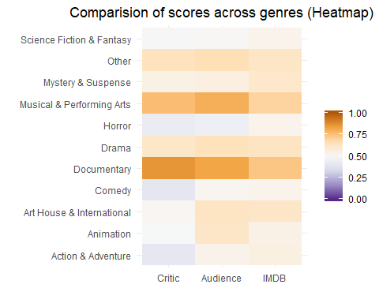

To compare the three different score types: Critic, Audience and IMDB to be comaral they must be rescaled as while Critic and Audience are of the range 1-100, IMDB is 1-10. After rescaling, to the range 0-1, a visual comparison of the different groups can be seen by arranging them on a heatmap.

The most striking feature is the lack of high scores for most genres, except for Documentary and Musical & Performing Arts. From the three groups Critics seem to be the most negative in their scoring, while Audience and IMDB to be more aligned. This clearly seen in Action & Adventure genre where Critics have a far lower score than the other two groups. This may be due to Critics having a different criteria on what constitutes a “good” movie but without details on the required metrics this is only speculation. Conversely though IMBD scores are most unaligned with the other groups for the two highest scoring genres, the reasoning for this can not be determined from the data available.

mean_score <-  
 data.frame(  
 "Score" = c(  
 mean(movies$imdb_rating)*10,  
 mean(movies$audience_score),  
 mean(movies$critics_score)  
 ),  
 "Source" = c("IMDB", "Audience", "Critics")  
 )  
  
plot_all <- ggplot(mean_score, aes(Score, Source)) +  
 geom_segment(aes(x = 0, y = Source, xend = Score, yend = Source,colour=Source) ) + theme_minimal() +  
 geom_point(aes( colour=Source) ) +  
 xlim(0, 88) +  
 theme(legend.position = "none",axis.title.x = element_blank(), axis.text.y = element_blank()) +  
 ggtitle("All genres")  
  
#Action and adventure  
action_adventure <- subset(movies, genre == "Action & Adventure")  
mean_score <-  
 data.frame(  
 "Score" = c(  
 mean(action_adventure$imdb_rating)*10,  
 mean(action_adventure$audience_score),  
 mean(action_adventure$critics_score)  
 ),  
 "Source" = c("IMDB", "Audience", "Critics")  
 )  
  
plot_action <- ggplot(mean_score, aes(Score, Source)) +  
 geom_segment(aes(x = 0, y = Source, xend = Score, yend = Source,colour=Source) ) + theme_minimal() +  
 geom_point(aes( colour=Source) ) +  
 xlim(0, 88) +  
 theme(legend.position = "none",axis.title.x = element_blank(),axis.title.y = element_blank(),axis.text.y = element_blank()) +  
 ggtitle("Action & Adventure")  
  
#Animation  
animation <- subset(movies, genre == "Animation")  
mean_score <-  
 data.frame(  
 "Score" = c(  
 mean(animation$imdb_rating)*10,  
 mean(animation$audience_score),  
 mean(animation$critics_score)  
 ),  
 "Source" = c("IMDB", "Audience", "Critics")  
 )  
  
plot_animation <- ggplot(mean_score, aes(Score, Source)) +  
 geom_segment(aes(x = 0, y = Source, xend = Score, yend = Source,colour=Source) ) + theme_minimal() +  
 geom_point(aes( colour=Source) ) + xlim(0, 88) + theme(legend.position = "none",axis.title.x = element_blank(),axis.title.y = element_blank(),axis.text.y = element_blank()) + ggtitle("Animation")  
  
#Art House & International  
art_house <- subset(movies, genre == "Art House & International")  
  
mean_score <-  
 data.frame(  
 "Score" = c(  
 mean(art_house$imdb_rating)*10,  
 mean(art_house$audience_score),  
 mean(art_house$critics_score)  
 ),  
 "Source" = c("IMDB", "Audience", "Critics")  
 )  
  
plot_art_house <- ggplot(mean_score, aes(Score, Source)) +  
 geom_segment(aes(x = 0, y = Source, xend = Score, yend = Source,colour=Source) ) + theme_minimal() +  
 geom_point(aes( colour=Source) ) + xlim(0, 88) + theme(legend.position = "none",axis.title.x = element_blank(),axis.text.y = element_blank()) + ggtitle("Art House & International")  
  
#Comedy  
comedy <- subset(movies, genre == "Comedy")  
  
mean_score <-  
 data.frame(  
 "Score" = c(  
 mean(comedy$imdb_rating)*10,  
 mean(comedy$audience_score),  
 mean(comedy$critics_score)  
 ),  
 "Source" = c("IMDB", "Audience", "Critics")  
 )  
plot_comedy <-ggplot(mean_score, aes(Score, Source)) +  
 geom_segment(aes(x = 0, y = Source, xend = Score, yend = Source,colour=Source) ) + theme_minimal() +  
 geom_point(aes( colour=Source) ) + xlim(0, 88) + theme(legend.position = "none",axis.title.x = element_blank(),axis.title.y = element_blank(),axis.text.y = element_blank()) + ggtitle("Comedy")  
  
#Documentary  
documentary <- subset(movies, genre == "Documentary")  
  
mean_score <-  
 data.frame(  
 "Score" = c(  
 mean(documentary$imdb_rating)*10,  
 mean(documentary$audience_score),  
 mean(documentary$critics_score)  
 ),  
 "Source" = c("IMDB", "Audience", "Critics")  
 )  
  
plot_documentary <- ggplot(mean_score, aes(Score, Source)) +  
 geom_segment(aes(x = 0, y = Source, xend = Score, yend = Source,colour=Source) ) + theme_minimal() +  
 geom_point(aes( colour=Source) ) + xlim(0, 88) + theme(legend.position = "none",axis.title.x = element_blank(),axis.title.y = element_blank(),axis.text.y = element_blank()) + ggtitle("Documentary")  
  
#Drama  
drama <- subset(movies, genre == "Drama")  
  
mean_score <-  
 data.frame(  
 "Score" = c(  
 mean(drama$imdb_rating)*10,  
 mean(drama$audience_score),  
 mean(drama$critics_score)  
 ),  
 "Source" = c("IMDB", "Audience", "Critics")  
 )  
  
plot_drama <- ggplot(mean_score, aes(Score, Source)) +  
 geom_segment(aes(x = 0, y = Source, xend = Score, yend = Source,colour=Source) ) + theme_minimal() +  
 geom_point(aes( colour=Source) ) + xlim(0, 88) + theme(legend.position = "none",axis.title.x = element_blank(),axis.text.y = element_blank()) + ggtitle("Drama")  
  
#Horror  
horror <- subset(movies, genre == "Horror")  
  
mean_score <-  
 data.frame(  
 "Score" = c(  
 mean(horror$imdb_rating)*10,  
 mean(horror$audience_score),  
 mean(horror$critics_score)  
 ),  
 "Source" = c("IMDB", "Audience", "Critics")  
 )  
  
plot_horror <- ggplot(mean_score, aes(Score, Source)) +  
 geom_segment(aes(x = 0, y = Source, xend = Score, yend = Source,colour=Source) ) + theme_minimal() +  
 geom_point(aes( colour=Source) ) + xlim(0, 88) + theme(legend.position = "none",axis.title.x = element_blank(),axis.title.y = element_blank(),axis.text.y = element_blank()) + ggtitle("Horror")  
  
#Musical & Performing Arts  
musical <- subset(movies, genre == "Musical & Performing Arts")  
  
mean_score <-  
 data.frame(  
 "Score" = c(  
 mean(musical$imdb_rating)*10,  
 mean(musical$audience_score),  
 mean(musical$critics_score)  
 ),  
 "Source" = c("IMDB", "Audience", "Critics")  
 )  
  
plot_musical <- ggplot(mean_score, aes(Score, Source)) +  
 geom_segment(aes(x = 0, y = Source, xend = Score, yend = Source,colour=Source) ) + theme_minimal() +  
 geom_point(aes( colour=Source) ) + xlim(0, 88) + theme(legend.position = "none",axis.text.y = element_blank()) + ggtitle("Musical & Performing Arts")  
  
#Mystery & Suspense  
mistery <- subset(movies, genre == "Mystery & Suspense")  
mean_score <-  
 data.frame(  
 "Score" = c(  
 mean(mistery$imdb_rating)*10,  
 mean(mistery$audience_score),  
 mean(mistery$critics_score)  
 ),  
 "Source" = c("IMDB", "Audience", "Critics")  
 )  
  
plot_mistery <- ggplot(mean_score, aes(Score, Source)) +  
 geom_segment(aes(x = 0, y = Source, xend = Score, yend = Source,colour=Source) ) + theme_minimal() +  
 geom_point(aes( colour=Source) ) + xlim(0, 88) + theme(legend.position = "none",axis.title.x = element_blank(),axis.title.y = element_blank(),axis.text.y = element_blank()) + ggtitle("Mystery & Suspense")  
  
#Other  
other <- subset(movies, genre == "Other")  
  
mean_score <-  
 data.frame(  
 "Score" = c(  
 mean(other$imdb_rating)*10,  
 mean(other$audience_score),  
 mean(other$critics_score)  
 ),  
 "Source" = c("IMDB", "Audience", "Critics")  
 )  
plot_other <- ggplot(mean_score, aes(Score, Source)) +  
 geom_segment(aes(x = 0, y = Source, xend = Score, yend = Source,colour=Source) ) + theme_minimal() +  
 geom_point(aes( colour=Source) ) + xlim(0, 88) + theme(legend.position = "none",axis.title.y = element_blank(),axis.text.y = element_blank()) + ggtitle("Other")  
  
#Science Fiction & Fantasy  
science <- subset(movies, genre == "Science Fiction & Fantasy")  
  
mean_score <-  
 data.frame(  
 "Score" = c(  
 mean(science$imdb_rating)*10,  
 mean(science$audience_score),  
 mean(science$critics_score)  
 ),  
 "Source" = c("IMDB", "Audience", "Critics")  
 )  
plot_science <- ggplot(mean_score, aes(Score, Source)) +  
 geom_segment(aes(x = 0, y = Source, xend = Score, yend = Source,colour=Source) ) + theme_minimal() +  
 geom_point(aes( colour=Source) ) + xlim(0, 88) + theme(legend.position = "none",axis.title.y = element_blank(),axis.text.y = element_blank()) + ggtitle("Science Fiction & Fantasy")  
  
#Combine the plots...  
plot_combined_genre <-ggarrange(  
 plot_all,  
 plot_action,  
 plot_animation,  
 plot_art_house,  
 plot_comedy,  
 plot_documentary,  
 plot_drama,  
 plot_horror,  
 plot_mistery,  
 plot_musical,  
 plot_other,  
 plot_science,  
 ncol = 3,  
 nrow = 4,common.legend = TRUE, legend="bottom")+  
 labs(title = "Comparision of scores across genres (Lollipop chart)", x = "", y="", fill="")+  
 theme(plot.title = element_text(hjust = 0.5))  
  
g2_1.2 <-plot_combined_genre  
g2_1.2

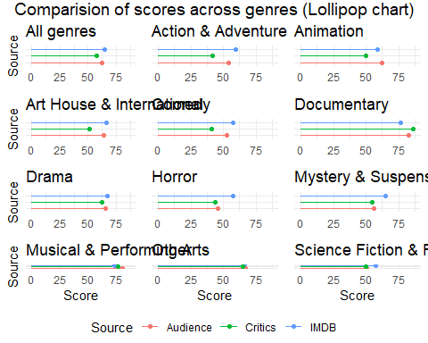

Taking a look at the different lollipop charts, we can see different things:

* Audience gives a higher score than Critics in 10/11 genres (90.9%). The only exception is the Documentary genre.
* IMDB gives a higher score than Critics in 9/11 genres (81.8%). The only exception is the Documentary and Musical & Performance genres.
* IMDB gives a higher score than Audience in 7/11 genres (63.6%).
* Genres like Documentary and Other receive similar ratings from all IMDB, Critics and Audience, whereas in genres like Comedy or Action & Adventure the ratings differ more.

Taking this into account, we can say that the pattern observed in previously is maintained in the individual genres. Critics give the lowest ratings for almost all genres and IMDB and Audience alternate in giving the highest score. There is a difference in the ratings of the different sources according to the genre and this difference follows a pattern, which is more accentuated in some genres than in others.

mean_score <-  
 data.frame(  
 "Score" = c(  
 mean(movies$imdb_rating)*10,  
 mean(movies$audience_score),  
 mean(movies$critics_score)  
 ),  
 "Source" = c("IMDB", "Audience", "Critics")  
 )  
  
plot_mpaa_all <- ggplot(mean_score, aes(Score, Source)) +  
 geom_segment(aes(x = 0, y = Source, xend = Score, yend = Source,colour=Source) ) + theme_minimal() +  
 geom_point(aes( colour=Source) ) + xlim(0,84) + theme(legend.position = "none",axis.title.x = element_blank(), axis.text.y = element_blank()) + ggtitle("All MPAA ratings")  
  
#G  
g <- subset(movies, mpaa_rating == "G")  
mean_score <-  
 data.frame(  
 "Score" = c(  
 mean(g$imdb_rating)*10,  
 mean(g$audience_score),  
 mean(g$critics_score)  
 ),  
 "Source" = c("IMDB", "Audience", "Critics")  
 )  
  
plot_g <- ggplot(mean_score, aes(Score, Source)) +  
 geom_segment(aes(x = 0, y = Source, xend = Score, yend = Source,colour=Source) ) + theme_minimal() +  
 geom_point(aes( colour=Source) ) + xlim(0,84) + theme(legend.position = "none",axis.title.x = element_blank(),axis.title.y = element_blank(),axis.text.y = element_blank()) + ggtitle("G")  
  
#NC-17  
nc_17 <- subset(movies, mpaa_rating == "NC-17")  
mean_score <-  
 data.frame(  
 "Score" = c(  
 mean(nc_17$imdb_rating)*10,  
 mean(nc_17$audience_score),  
 mean(nc_17$critics_score)  
 ),  
 "Source" = c("IMDB", "Audience", "Critics")  
 )  
  
plot_nc_17 <- ggplot(mean_score, aes(Score, Source)) +  
 geom_segment(aes(x = 0, y = Source, xend = Score, yend = Source,colour=Source) ) + theme_minimal() +  
 geom_point(aes( colour=Source) ) + xlim(0,84) + theme(legend.position = "none",axis.title.x = element_blank(),axis.title.y = element_blank(),axis.text.y = element_blank()) + ggtitle("NC-17")  
  
#PG  
pg <- subset(movies, mpaa_rating == "PG")  
  
mean_score <-  
 data.frame(  
 "Score" = c(  
 mean(pg$imdb_rating)*10,  
 mean(pg$audience_score),  
 mean(pg$critics_score)  
 ),  
 "Source" = c("IMDB", "Audience", "Critics")  
 )  
  
plot_pg <- ggplot(mean_score, aes(Score, Source)) +  
 geom_segment(aes(x = 0, y = Source, xend = Score, yend = Source,colour=Source) ) + theme_minimal() +  
 geom_point(aes( colour=Source) ) + xlim(0,84) + theme(legend.position = "none",axis.title.x = element_blank(),axis.text.y = element_blank()) + ggtitle("PG")  
  
#PG-13  
pg_13 <- subset(movies, mpaa_rating == "PG-13")  
  
mean_score <-  
 data.frame(  
 "Score" = c(  
 mean(pg_13$imdb_rating)*10,  
 mean(pg_13$audience_score),  
 mean(pg_13$critics_score)  
 ),  
 "Source" = c("IMDB", "Audience", "Critics")  
 )  
plot_pg_13 <-ggplot(mean_score, aes(Score, Source)) +  
 geom_segment(aes(x = 0, y = Source, xend = Score, yend = Source,colour=Source) ) + theme_minimal() +  
 geom_point(aes( colour=Source) ) + xlim(0,84) + theme(legend.position = "none",axis.title.y = element_blank(),axis.text.y = element_blank()) + ggtitle("PG-13")  
  
#R  
r <- subset(movies, mpaa_rating == "R")  
  
mean_score <-  
 data.frame(  
 "Score" = c(  
 mean(r$imdb_rating)*10,  
 mean(r$audience_score),  
 mean(r$critics_score)  
 ),  
 "Source" = c("IMDB", "Audience", "Critics")  
 )  
  
plot_r <- ggplot(mean_score, aes(Score, Source)) +  
 geom_segment(aes(x = 0, y = Source, xend = Score, yend = Source,colour=Source) ) + theme_minimal() +  
 geom_point(aes( colour=Source) ) + xlim(0,84) + theme(legend.position = "none",axis.title.y = element_blank(),axis.text.y = element_blank()) + ggtitle("R")  
  
#Unrated  
unrated <- subset(movies, mpaa_rating == "Unrated")  
  
mean_score <-  
 data.frame(  
 "Score" = c(  
 mean(unrated$imdb_rating)*10,  
 mean(unrated$audience_score),  
 mean(unrated$critics_score)  
 ),  
 "Source" = c("IMDB", "Audience", "Critics")  
 )  
  
plot_unrated <- ggplot(mean_score, aes(Score, Source)) +  
 geom_segment(aes(x = 0, y = Source, xend = Score, yend = Source,colour=Source) ) + theme_minimal() +  
 geom_point(aes( colour=Source) ) + xlim(0,84) + theme(legend.position = "none",axis.text.y = element_blank()) + ggtitle("Unrated")  
  
  
#Combine the plots...  
plot_combined_mpaa <-ggarrange(  
 plot_mpaa_all,  
 plot_g,  
 plot_nc_17,  
 plot_pg,  
 plot_pg_13,  
 plot_r,  
 plot_unrated,  
 ncol = 4,  
 nrow = 2,common.legend = TRUE, legend="bottom")+  
 labs(title = "Comparision of scores across MPAA ratings (Lollipop chart)", x = "", y="", fill="")+  
 theme(plot.title = element_text(hjust = 0.5))  
  
  
g2_2 <-plot_combined_mpaa  
g2_2

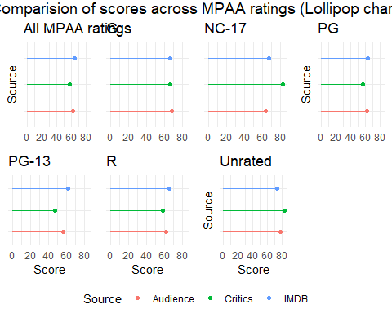

If we now make a similar comparison for the MPAA ratings, we can see the following:

* Audience gives a higher score than Critics in 4/6 MPAA ratings (66.6%). The two MPAA ratings where Critics give a higher score are NC-17 and Unrated.
* IMDB gives a higher score than Critics in 4/6 MPAA ratings (66.6%). Again, the two exceptions are NC-17 and Unrated.
* IMDB tends to give a higher score than Audience. This happens, again, in 4/6 MPAA ratings (66.6%). The MPAA ratings where this does not happen are G and Unrated.
* Exceptuating G and PG, the rest of the MPAA ratings receive clearly different, although not highly, scores from the three different sources.

From these findings we can see that overall IMDB and the Audience tend to give more positive reviews than the Critics. However, the scores given by the three sources are not that different one from the other in the majority of the MPAA ratings (the only exceptions being the extreme Critics score for NC-17 and PG-13). Therefore, there is not enough evidence to say that there is a significant difference in the score according to the MPAA rating.

## 3. Comparison best picture/oscar nominated and score/oscar nominated

### - Are oscar-awarded films more liked?

# This is figure 3.1 in the Document  
g3_1_1 <- ggplot(data=movies, aes(x = best_pic_nom, y = audience_score, group = best_pic_nom, fill = best_pic_nom)) +  
 geom_boxplot(alpha = .7) +  
 geom_jitter(width = .05, alpha = .4) +  
 guides(fill = "none") +  
 theme_minimal() +  
 labs(x = "Best picture nomination", y = "Audience score")  
  
g3_1_2 <- ggplot(data=movies, aes(x = best_actor_win, y = audience_score, group = best_actor_win, fill = best_actor_win)) +  
 geom_boxplot(alpha = .7) +  
 geom_jitter(width = .05, alpha = .4) +  
 guides(fill = "none") +  
 theme_minimal() +  
 labs(x = "Best actor win", y=" ")   
  
g3_1_3 <- ggplot(data=movies, aes(x = best_actress_win, y = audience_score, group = best_actress_win, fill = best_actress_win)) +  
 geom_boxplot(alpha = .7) +  
 geom_jitter(width = .05, alpha = .4) +  
 guides(fill = "none") +  
 theme_minimal()+  
 labs(x = "Best actress win", y=" ")   
  
g3_1_4 <- ggplot(data=movies, aes(x = best_dir_win, y = audience_score, group = best_dir_win, fill = best_dir_win)) +  
 geom_boxplot(alpha = .7) +  
 geom_jitter(width = .05, alpha = .4) +  
 guides(fill = "none") +  
 theme_minimal() +  
labs(x = "Best director win", y=" ")   
  
g3_1 <- ggarrange(  
 g3_1_1,  
 g3_1_2,  
 g3_1_3,  
 g3_1_4,  
 ncol = 4,  
 nrow = 1,  
 widths = c(200)  
 ) %>% annotate_figure(top = text_grob("Score comparison of nominated and awarded movies (box plot)", face = "bold"))  
  
g3_1

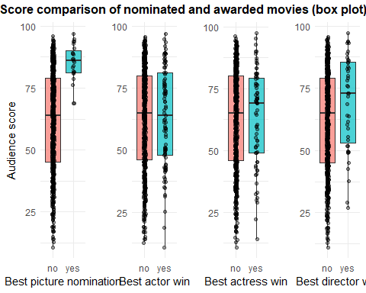

g3_2_1 <- ggplot(data=movies, aes(x = best_pic_nom, y = audience_score, group = best_pic_nom, fill = best_pic_nom)) +  
 geom_boxplot(alpha = .7) +  
 geom_jitter(width = .05, alpha = .4) +  
 guides(fill = "none") +  
 theme_minimal()+  
 labs(x = "Best picture nomination", y="Audience score")  
  
g3_2_2 <- ggplot(data=movies, aes(x = best_pic_nom, y = critics_score, group = best_pic_nom, fill = best_pic_nom)) +  
 geom_boxplot(alpha = .7) +  
 geom_jitter(width = .05, alpha = .4) +  
 guides(fill = "none") +   
 theme_minimal()+  
 labs(x = "Best picture nomination", y="Critics score")  
  
g3_2_3 <- ggplot(data=movies, aes(x = best_pic_nom, y = imdb_rating, group = best_pic_nom, fill = best_pic_nom)) +  
 geom_boxplot(alpha = .7) +  
 geom_jitter(width = .05, alpha = .4) +  
 guides(fill = "none") +   
 theme_minimal()+  
 labs(x = "Best picture nomination", y="IMDB rating")  
  
g3_2 <- ggarrange(  
 g3_2_1,  
 g3_2_2,  
 g3_2_3,  
 ncol = 3,  
 nrow = 1  
 ) %>% annotate_figure(top = text_grob("Score comparison of nominated and awarded movies by different critics (box plot)", face = "bold"))  
  
g3_2

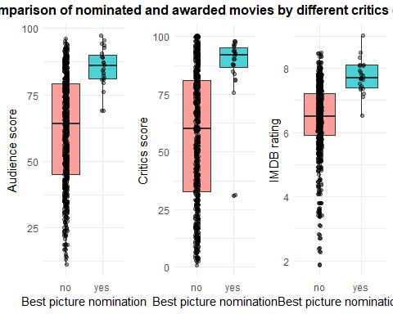

g3_3_1 <- ggplot(aes(x=best_actor_win), data=movies[movies$best_pic_nom=="yes",]) +  
 geom_bar(aes( fill = best_dir_win), show.legend = FALSE) +  
 theme_minimal() +  
 xlab("Has the actor been awarded?") +   
 ylab("Number of samples") +  
 scale_fill_discrete("Best actor")  
  
g3_3_2 <- ggplot(aes(x=best_actress_win), data=movies[movies$best_pic_nom=="yes",]) +  
 geom_bar(aes( fill = best_dir_win), show.legend = FALSE) +  
 theme_minimal() +  
 xlab("Has the actress been awarded?") +   
 ylab(" ") +  
 scale_fill_discrete("Best actress")  
  
g3_3_3 <- ggplot(aes(x=best_dir_win), data=movies[movies$best_pic_nom=="yes",]) +  
 geom_bar(aes( fill = best_dir_win)) +  
 theme_minimal() +  
 xlab("Has the director been awarded") +   
 ylab(" ") +  
 scale_fill_discrete("Best director")  
  
g3_3 <- ggarrange(  
 g3_3_1,  
 g3_3_2,  
 g3_3_3,  
 ncol = 3,  
 nrow = 1,  
 widths = c(200,200,300),  
 labels = c("1", "2", "3","4")  
 ) %>% annotate_figure(top = text_grob("Relationship between awarded cast members and awarded directors", face = "bold"))  
  
g3_3

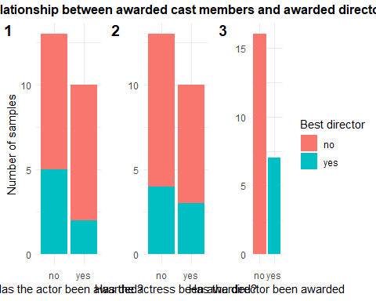

best_pic_movies <- subset(movies, c(best_pic_win == "yes"))  
  
 #Add a column showing if they have won another award  
 best_pic_movies$other_win <- NA  
  
 if (best_pic_movies$best_actor_win == "yes" ||  
 best_pic_movies$best_actress_win == "yes" ||  
 best_pic_movies$best_dir_win == "yes") {  
 best_pic_movies$other_win <- "yes"  
 } else{  
 best_pic_movies$other_win <- "no"  
 }  
  
 #Plots...  
 #Best movies that have won another award  
 best_movie_another_award <- plyr::count(best_pic_movies$other_win)  
 best_movie_another_award <- best_movie_another_award %>%  
 arrange((freq)) %>%  
 mutate(lab.ypos = cumsum(freq) - 0.5 * freq)  
  
 pie_another_award <-  
 ggplot(best_movie_another_award, aes(x = "", y = freq, fill = x)) +  
 geom_bar(width = 1,  
 stat = "identity",  
 color = "white") +  
 coord_polar("y", start = 0) +  
 theme_void() +  
 geom_text(aes(label = signif((freq / 7) * 100), digits = 2),  
 position = position_stack(vjust = 0.5),  
 color = "white") +  
 labs(fill = "Another award") +  
 ggtitle("Best movies w/ awarded member") +  
 theme(plot.title = element_text(size = 12, hjust = 0.5)) +  
 scale_fill_manual(values = "#00BFC4")

## Warning: Ignoring unknown aesthetics: digits

#Best movies that have won best actor award  
 best_movie_best_actor <- plyr::count(best_pic_movies$best_actor_win)  
 best_movie_best_actor <- best_movie_best_actor %>%  
 arrange((freq)) %>%  
 mutate(lab.ypos = cumsum(freq) - 0.5 * freq)  
  
 pie_best_actor <-  
 ggplot(best_movie_best_actor, aes(x = "", y = freq, fill = x)) +  
 geom_bar(width = 1,  
 stat = "identity",  
 color = "white") +  
 coord_polar("y", start = 0) +  
 theme_void() +  
 geom_text(aes(label = signif((freq / 7) * 100), digits = 2),  
 position = position_stack(vjust = 0.5),  
 color = "white") +  
 labs(fill = "Best actor") +  
 ggtitle("Best movies w/ best actor") +  
 theme(plot.title = element_text(size = 12, hjust = 0.5))

## Warning: Ignoring unknown aesthetics: digits

#Best movies that have won best actress award  
 best_movie_best_actress <- plyr::count(best_pic_movies$best_actress_win)  
 best_movie_best_actress <- best_movie_best_actress %>%  
 arrange((freq)) %>%  
 mutate(lab.ypos = cumsum(freq) - 1 * freq)  
  
 pie_best_actress <-  
 ggplot(best_movie_best_actress, aes(x = "", y = freq, fill = x)) +  
 geom_bar(width = 1,  
 stat = "identity",  
 color = "white") +  
 coord_polar("y", start = 0) +  
 theme_void() +  
 geom_text(aes(label = signif((freq / 7) * 100), digits = 2),  
 position = position_stack(vjust = 0.5),  
 color = "white") +  
 labs(fill = "Best actress") +  
 ggtitle("Best movies w/ best actress") +  
 theme(plot.title = element_text(size = 12, hjust = 0.5))

## Warning: Ignoring unknown aesthetics: digits

#Best movies that have won best director award  
 best_movie_best_director <- plyr::count(best_pic_movies$best_dir_win)  
 best_movie_best_director <- best_movie_best_director %>%  
 arrange((freq)) %>%  
 mutate(lab.ypos = cumsum(freq) - 0.9 * freq)  
  
 pie_best_director <-  
 ggplot(best_movie_best_director, aes(x = "", y = freq, fill = x)) +  
 geom_bar(width = 1,  
 stat = "identity",  
 color = "white") +  
 coord_polar("y", start = 0) +  
 theme_void() +  
 geom_text(aes(label = signif((freq / 7) * 100), digits = 2),  
 position = position_stack(vjust = 0.5),  
 color = "white") +  
 labs(fill = "Best director") +  
 ggtitle("Best movies w/ best director") +  
 theme(plot.title = element_text(size = 12, hjust = 0.5))

## Warning: Ignoring unknown aesthetics: digits

#Combine plots!  
 plot_combined_awarded <-  
 ggarrange(  
 pie_another_award,  
 pie_best_actor,  
 pie_best_actress,  
 pie_best_director,  
 ncol = 2,  
 nrow = 2,  
 widths = c(400,400,400,400)  
 )+  
 labs(title = "Proportion of awards in the best movies (Pie chart)", x = "", y="", fill="")+  
 theme(plot.title = element_text(hjust = 0.5))  
  
g3_4 <- plot_combined_awarded  
g3_4

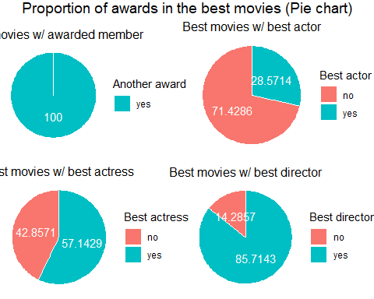

Looking at the pie charts, we can see that the movies in the dataset that have received the award for best film always have a cast/crew member with another award. It must be taken into account that the actors, actresses and directors could have received their award at any point in their career, not necessarily for the awarded film in which they participate. That is, the pie charts are not meant to show that if a cast/crew member receives an award for one film, that film is more likely to be awarded itself. However, the plots can serve to study the relationship between having high quality professionals working in a movie and that movie receiving an award.

Considering this, we can see that most awarded movies in this dataset have a director that has or will receive an award. The presence of awarded directors in 6/7 movies highly surpasses the proportion of awarded movies with awarded actors and actresses. This hints that the quality of the director is more influential than that of the actors and actresses in determining if the movie is awarded for best film. This deduction makes sense, since actors are only responsible for playing their roles whereas the director’s decisions involve all the elements of a film.

## 4. What are the trends over the years?

### - Preferred month for releases? number of films by month (over the years?)

We start to count the movies per months to see if there is a pattern in all this time in the release months.

g4_1_1 <- ggplot(movies, aes(fill = thtr_rel_decade)) +   
 geom_bar(aes(x = thtr_rel_month, (..count..)/sum(..count..))) +   
 theme_minimal() +  
 xlab("Month") +   
 ylab("Percentage of Movies") +  
 ggtitle("Percentage of Movies released per month each decade ") +   
 scale_fill_discrete(name = "Decade", labels=c("70's","80's","90's","00's","10's")) +   
 scale_x_continuous(breaks=1:12,labels=c("Jan", "Feb", "Mar", "Apr","May", "Jun", "Jul", "Aug", "Sept", "Oct", "Nov", "Dec")) +  
 scale_y_continuous(labels=scales::percent)  
  
g4_1_1

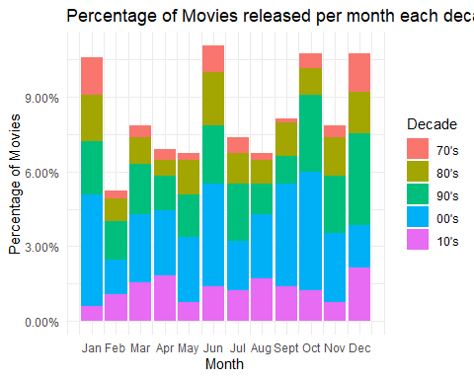

We can see that overall there is a “pattern” of releases in the months of January, June, October and December, so let’s take a better look at this data by decade. We breakdown the previous graphs grouping the data by decade.

g4_1_2 <- ggplot(movies, aes(fill = thtr_rel_decade)) +  
 geom_bar(aes(x = thtr_rel_month), width = 0.5, show.legend = FALSE) +  
 facet_wrap(thtr_rel_decade ~ ., nrow = 1) +  
 #facet_wrap(facets = "thtr_rel_decade", ) +  
 theme_minimal() + theme(axis.text.x = element_text(angle = 45, hjust = 1)) +   
 xlab("Month") +  
 ylab("Number of Movies") +  
 ggtitle("Number of Movies released per month each decade with breakdown") +  
 scale_fill_discrete(name = "Decade", labels=c("70's","80's","90's","00's","10's")) +   
 scale_x_continuous(breaks=1:12,labels=c("Jan", "Feb", "Mar", "Apr","May", "Jun", "Jul", "Aug", "Sept", "Oct", "Nov", "Dec"))   
  
g4_1_2

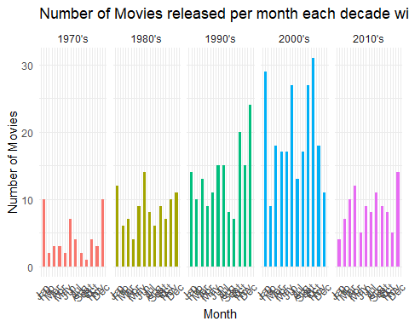

g4_1_3 <-ggplot(movies, aes(fill = thtr_rel_decade)) +  
 geom_bar(aes(x = thtr_rel_month, y = (..prop..)), width = 0.5, show.legend = FALSE) +  
 facet_wrap(thtr_rel_decade ~ ., nrow = 1) +  
 theme_minimal() + theme(axis.text.x = element_text(angle = 90, hjust = 1)) +   
 xlab(" ") +  
 ylab("Percentage of Films") +  
 ggtitle("Percentage of Films released per month each decade with breakdown ") +  
 scale_fill_discrete(name = "Decade", labels=c("70's","80's","90's","00's","10's")) +  
 scale_x_continuous(breaks=1:12,labels=c("Jan", "Feb", "Mar", "Apr","May", "Jun", "Jul", "Aug", "Sept", "Oct", "Nov", "Dec")) +  
 scale_y_continuous(labels=scales::percent)  
  
g4_1_3

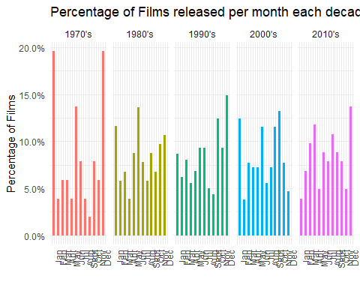

Now we can see clearly that since the 70’s there has been a trend of two moments in the years to release movies in theaters: in summer (June) and in the winter Holidays (December and January). However, in this last decade, we only see a spike in December.

### - Does the genre change over the years (by decade)?

We start by plotting the films separated by genre and gruped by decade in color.

g4_2_1 <- ggplot(movies, aes(fill = thtr_rel_decade)) +  
 geom_bar(aes(x = genre, y = (..count..)/sum(..count..))) +   
 #facet_wrap(thtr_rel_decade ~ ., nrow = 1) +  
 theme_minimal() +   
 xlab("Genres") +  
 ylab("% of Films") +  
 ggtitle("Genre of Films released each decade w/ breakdown") +   
 scale_fill_discrete(name = "Decade", labels=c("70's","80's","90's","00's","10's")) +  
 scale_y_continuous(labels=scales::percent) +  
 coord_flip()  
  
g4_2_1

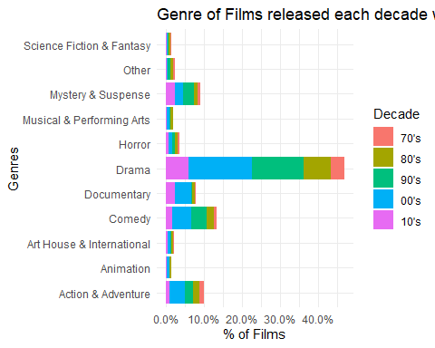 > Now we will do a breakdown on the graph:

# All the plots individually:  
g4_2_2 <- ggplot(movies[movies$thtr_rel_decade==1970,]) +  
 geom_bar(aes(x = genre, y = (..count..)/sum(..count..)), fill = 'tomato') +   
 facet_wrap(thtr_rel_decade ~ ., nrow = 2) +  
 theme_minimal() +  
 xlab("Genres") +  
 ylab("% of Films") +  
 ggtitle("Genre of Films released each decade w/ breakdown") +   
 scale_y_continuous(labels=scales::percent) +  
 coord_flip()  
  
g4_2_3 <- ggplot(movies[movies$thtr_rel_decade==1980,]) +  
 geom_bar(aes(x = genre, y = (..count..)/sum(..count..)), fill = 'gold') +   
 facet_wrap(thtr_rel_decade ~ ., nrow = 2) +  
 theme_minimal() +  
 xlab("Genres") +  
 ylab("% of Films") +  
 ggtitle("Genre of Films released each decade w/ breakdown") +   
 scale_y_continuous(labels=scales::percent) +  
 coord_flip()  
  
g4_2_4 <- ggplot(movies[movies$thtr_rel_decade==1990,]) +  
 geom_bar(aes(x = genre, y = (..count..)/sum(..count..)), fill = 'limegreen') +   
 facet_wrap(thtr_rel_decade ~ ., nrow = 2) +  
 theme_minimal() +  
 xlab("Genres") +  
 ylab("% of Films") +  
 ggtitle("Genre of Films released each decade w/ breakdown") +   
 scale_y_continuous(labels=scales::percent) +  
 coord_flip()  
  
g4_2_5 <- ggplot(movies[movies$thtr_rel_decade==2000,]) +  
 geom_bar(aes(x = genre, y = (..count..)/sum(..count..)), fill = 'skyblue') +   
 facet_wrap(thtr_rel_decade ~ ., nrow = 2) +  
 theme_minimal() +   
 xlab("Genres") +  
 ylab("% of Films") +  
 ggtitle("Genre of Films released each decade w/ breakdown") +   
 scale_y_continuous(labels=scales::percent) +  
 coord_flip()  
  
g4_2_6 <- ggplot(movies[movies$thtr_rel_decade==2010,]) +  
 geom_bar(aes(x = genre, y = (..count..)/sum(..count..)), fill = 'orchid') +   
 facet_wrap(thtr_rel_decade ~ ., nrow = 2) +  
 theme_minimal() +   
 xlab("Genres") +  
 ylab("% of Films") +  
 ggtitle("Genre of Films released each decade w/ breakdown") +   
 scale_y_continuous(labels=scales::percent) +  
 coord_flip()  
  
# Facewrap of all the plots  
g4_2_7.1 <- ggplot(movies, aes(fill = thtr_rel_decade)) +  
 geom_bar(aes(x = genre, y = (..count..)/sum(..count..))) +   
 # all options & modifiers   
 facet_wrap(thtr_rel_decade ~ ., nrow = 2) +  
 theme_minimal() +   
 xlab("Genres") +  
 ylab("% of Films") +  
 ggtitle("Genre of Films released each decade w/ breakdown") +   
 scale_fill_discrete(name = "Decade", labels=c("70's","80's","90's","00's","10's")) +  
 scale_y_continuous(labels=scales::percent) +  
 coord_flip()  
  
# g4_2_7.2 <- ggarrange(  
# g4_2_2,  
# g4_2_3,  
# g4_2_4,  
# g4_2_5,  
# g4_2_6,  
# ncol = 3,  
# nrow = 2  
# ) %>% annotate_figure(top = text_grob("Relationship between awarded cast members and awarded directors", face = "bold"))  
  
g4_2_7.1

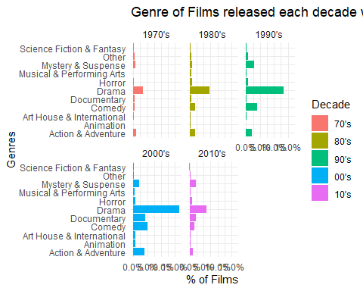

We can see an increment over the years in the Documentary Genre, as well as in Mystery and Suspense.

### - Do older films tend to have higher score/number of votes? if this is true, it could be because only good old films get remembered

Let’s see what is the amount of votes over the years that we have for all the films.

g4_2_1 <- ggplot(movies, aes(fill = thtr_rel_date)) +  
 geom_smooth(aes(x = thtr_rel_date, y = imdb_num_votes), color = 'tomato', show.legend = FALSE) +  
 geom_jitter(aes(x = thtr_rel_date, y = imdb_num_votes), color = 'limegreen', alpha = '0.5' , show.legend = FALSE) +  
 theme_minimal() +  
 xlab("Date") +  
 ylab("Number of Votes") +  
 ggtitle("Number of movie rating vote over the years")  
  
g4_2_1

## `geom_smooth()` using method = 'loess' and formula 'y ~ x'

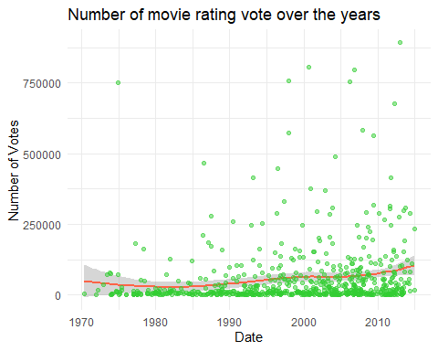

Okay so it seems like the number of votes does increase over the years, but does it afect the overall score?

g4_2_2 <- ggplot(movies, aes(fill = thtr_rel_date)) +  
 geom_smooth(aes(x = thtr_rel_date, y = imdb_rating), color = 'tomato', show.legend = FALSE) +  
 theme_minimal() +  
 xlab("Date") +  
 ylab("Rating") +  
 ylim (0, 10) +  
 ggtitle("Rating of movies over the years")  
  
ggarrange(g4_2_1, g4_2_2)

## `geom_smooth()` using method = 'loess' and formula 'y ~ x'  
## `geom_smooth()` using method = 'loess' and formula 'y ~ x'

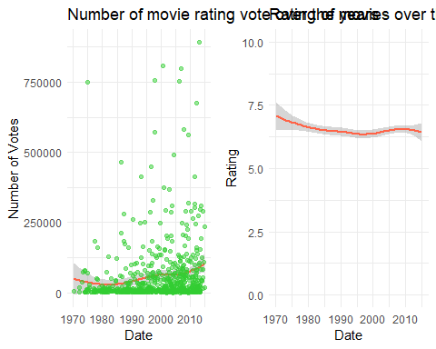 > Let’s zoom to see if we can see more clearly if there is some change

ggplot(movies, aes(fill = thtr_rel_date)) +  
 geom_smooth(aes(x = thtr_rel_date, y = imdb_rating), color = 'tomato') +  
 theme_minimal() +  
 xlab("Date") +  
 ylab("Rating") +  
 #ylim (6.5, 7.5) +  
 ggtitle("Zoom: rating of movies over the years")

## `geom_smooth()` using method = 'loess' and formula 'y ~ x'

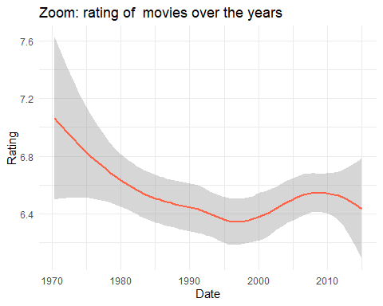

We can clearly see a decrease in overall score of this movies, but since it’s really minimal, it could also be because of random ratings variation.

ggplot(data=movies, aes(x=thtr_rel_date, y=audience_score)) + geom_point(aes(col=best_pic_nom), size=3)

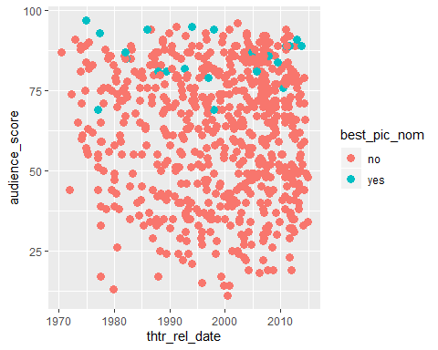

commonTheme = list(labs(color="Density",fill="Density", x="Date", y="Overall score"))  
ggplot(data=movies,aes(thtr_rel_date, audience_score)) +   
 stat_density2d(aes(fill=..level..,alpha=..level..),geom='polygon',colour='black') +   
 scale_fill_continuous(low="green",high="red") +  
 guides(alpha="none") +  
 theme_minimal() +  
 commonTheme

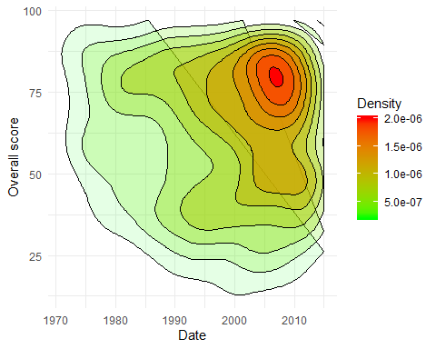

commonTheme = list(labs(color="Density",fill="Density", x="Runtime", y="Overall score"))  
ggplot(data=movies,aes(runtime, audience_score)) +   
 stat_density2d(aes(fill=..level..,alpha=..level..),geom='polygon',colour='black') +   
 scale_fill_continuous(low="green",high="red") +  
 guides(alpha="none") +   
 theme_minimal() +  
 commonTheme

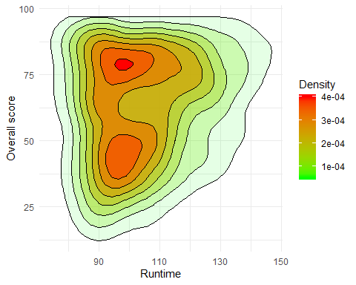

## 5. Do actors and directors have a higher score once they won? (find the first film and see the tendency, look for sudden change)

best_dirs = subset(movies, movies$best_dir_win == "yes") %>%  
 group_by(director) %>%  
 filter(n() > 2)  
  
win_years = data.frame(  
 year = c(2010, 2007,1987, 1990, 1978),  
 director=c("Kathryn Bigelow", "Martin Scorsese","Oliver Stone","Oliver Stone","Woody Allen")  
)  
  
win_year_intersects =   
 geom_vline(data = win_years, aes(xintercept=year, color = director), show.legend = FALSE)  
  
p1 = ggplot(best_dirs, aes(y=critics_score, x=thtr_rel_year, color=director))+  
 geom_point()+  
 geom_line(show.legend = FALSE) +  
 labs(title = "Oscar winning director movie scores", y = "Critics Score", x = "", color="Movie Released")+ theme_minimal() +  
 theme(plot.title = element_text(hjust = 0.5),  
 axis.text.x=element_blank(),  
 axis.ticks.x=element_blank())+  
 ylim(1,100)+  
 win_year_intersects  
  
p2 = ggplot(best_dirs, aes(y=audience_score, x=thtr_rel_year, color=director),limits = c(1,100))+  
 geom_point()+  
 geom_line() +  
 labs(y = "Audience Score", x = "")+ theme_minimal() +  
 theme(axis.text.x=element_blank(),  
 axis.ticks.x=element_blank())+  
 ylim(1,100)+  
 win_year_intersects  
  
p3= ggplot(best_dirs, aes(y=imdb_rating, x=thtr_rel_year, color=director))+ theme_minimal() +  
 geom_point()+  
 geom_line() +  
 labs(y = "IMDB Rating", x = "Film Release Year")+   
 ylim(1,10)+  
 win_year_intersects  
  
ggarrange(p1, p2, p3, nrow = 3, common.legend = TRUE, legend="bottom")

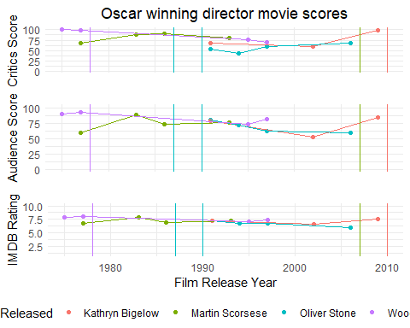

To answer this question we visualized if the likelyhood of winning a director Oscar could be predicted by the tread of a director review scores. It was decided to only include those that had directed more than two movies to be able to properly chart their successes over the years. By plotting each director’s movie releases (points) against the three differnt score categories we can see that most have a aarying level of succsess over the years It can be seen the comparisons between the three groups vary but they approximately show the same trajectory for the directors over the years. It should be noted that in all three scoring categories only U-Turn releasede in 1997 and directed by Oliver Stone, scored less than half the available points. It can be shown then that, based on the available data, that directors win win Oscars have high scoring films.

To see if these trends indcated likelyhood of winning an Oscar the years each director has won the best direct awrd were added to the plot using vertical lines. Unfortuanly due to the lack of data available in the dataset it is not possible to confidently determine any information. It could be speculated that a ariectors highest scoringmovie will win them an Oscar by looking at the data for Kathryn Bigelow and Woodly Allen. But as the movies won by Martin Scorses and Oliver Stone are not present in the dataset it is not possible to see the score trends at these times in their careers. Thus we are not able to answer the puestion we proposed. To be able to give a concrete answer for this question a larger dataset will be required. This idealy would not only include missing movies for the directors shown but for those removed for having insufficent having entries records.